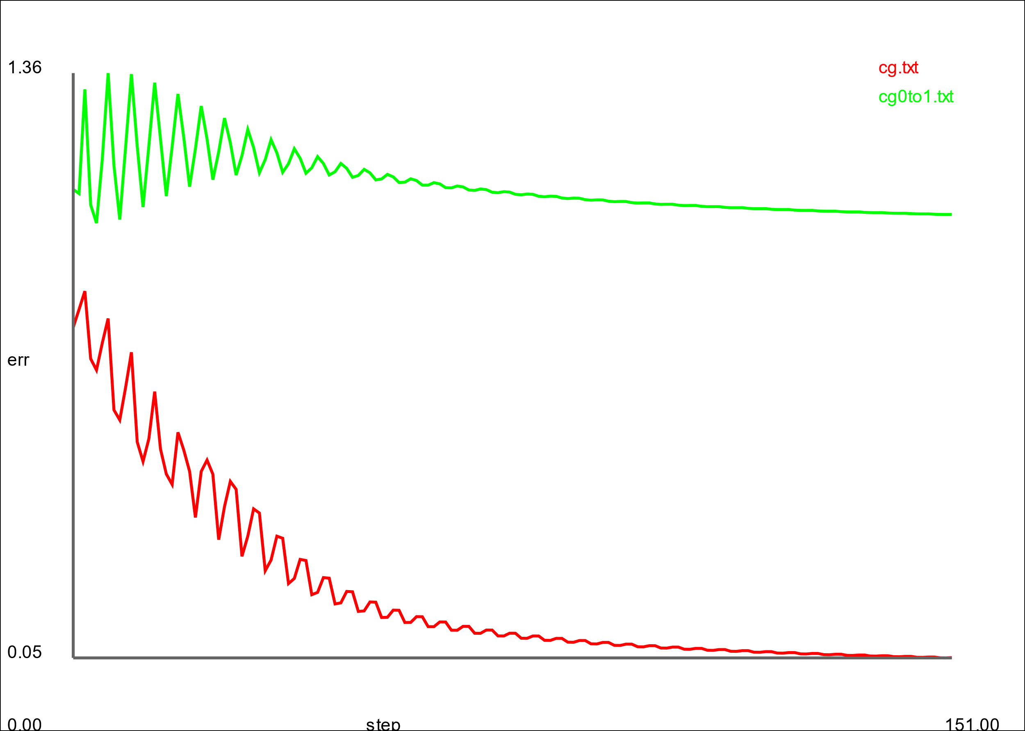

Since the target of the red is 0 it is trying to make the error as close to 0 as possible. Since for the green line we made the target 1, the error is trying to get as close to 1 as possible.

In Ex3.cpp, the error starts around 0.25 where it goes down to around 0.16 after the training has finished. Since this causes them to have the same weight they overshoot the minimum value.

1. = too big of error

0.01 = too big of error

0.1 = too big of error

1.0 = error small enough

10.0 = too big of error

This is happening because there is a sweet spot in the code where the deviation of the code is just right where the error is low enough. If the deviation is too high or low then it does not work and the error becomes too high. This is because if the deviation is too big or too low then it may overshoot the minimum value.